**Name:** Nnadiekwe David Chiderah

***AMI Creation***

* ***Launch an EC2 instance and install and configure an Apache HTTP server on it, as outlined in your previous homework assignment.***

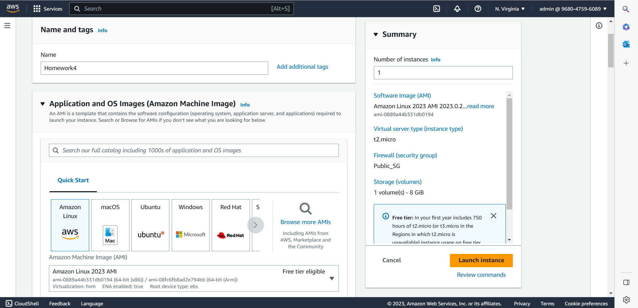

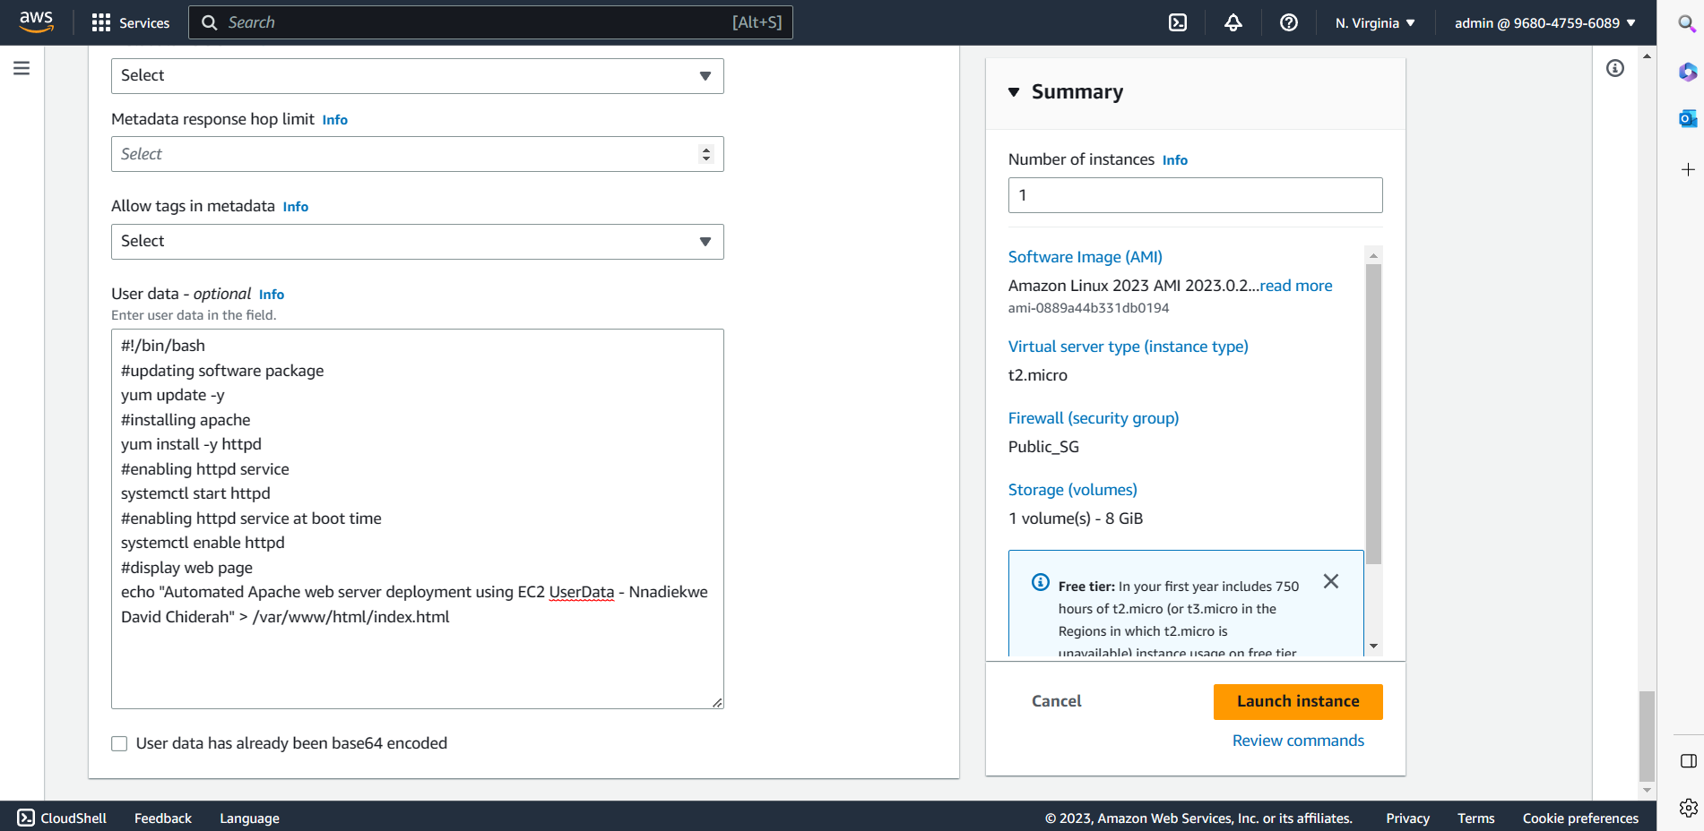

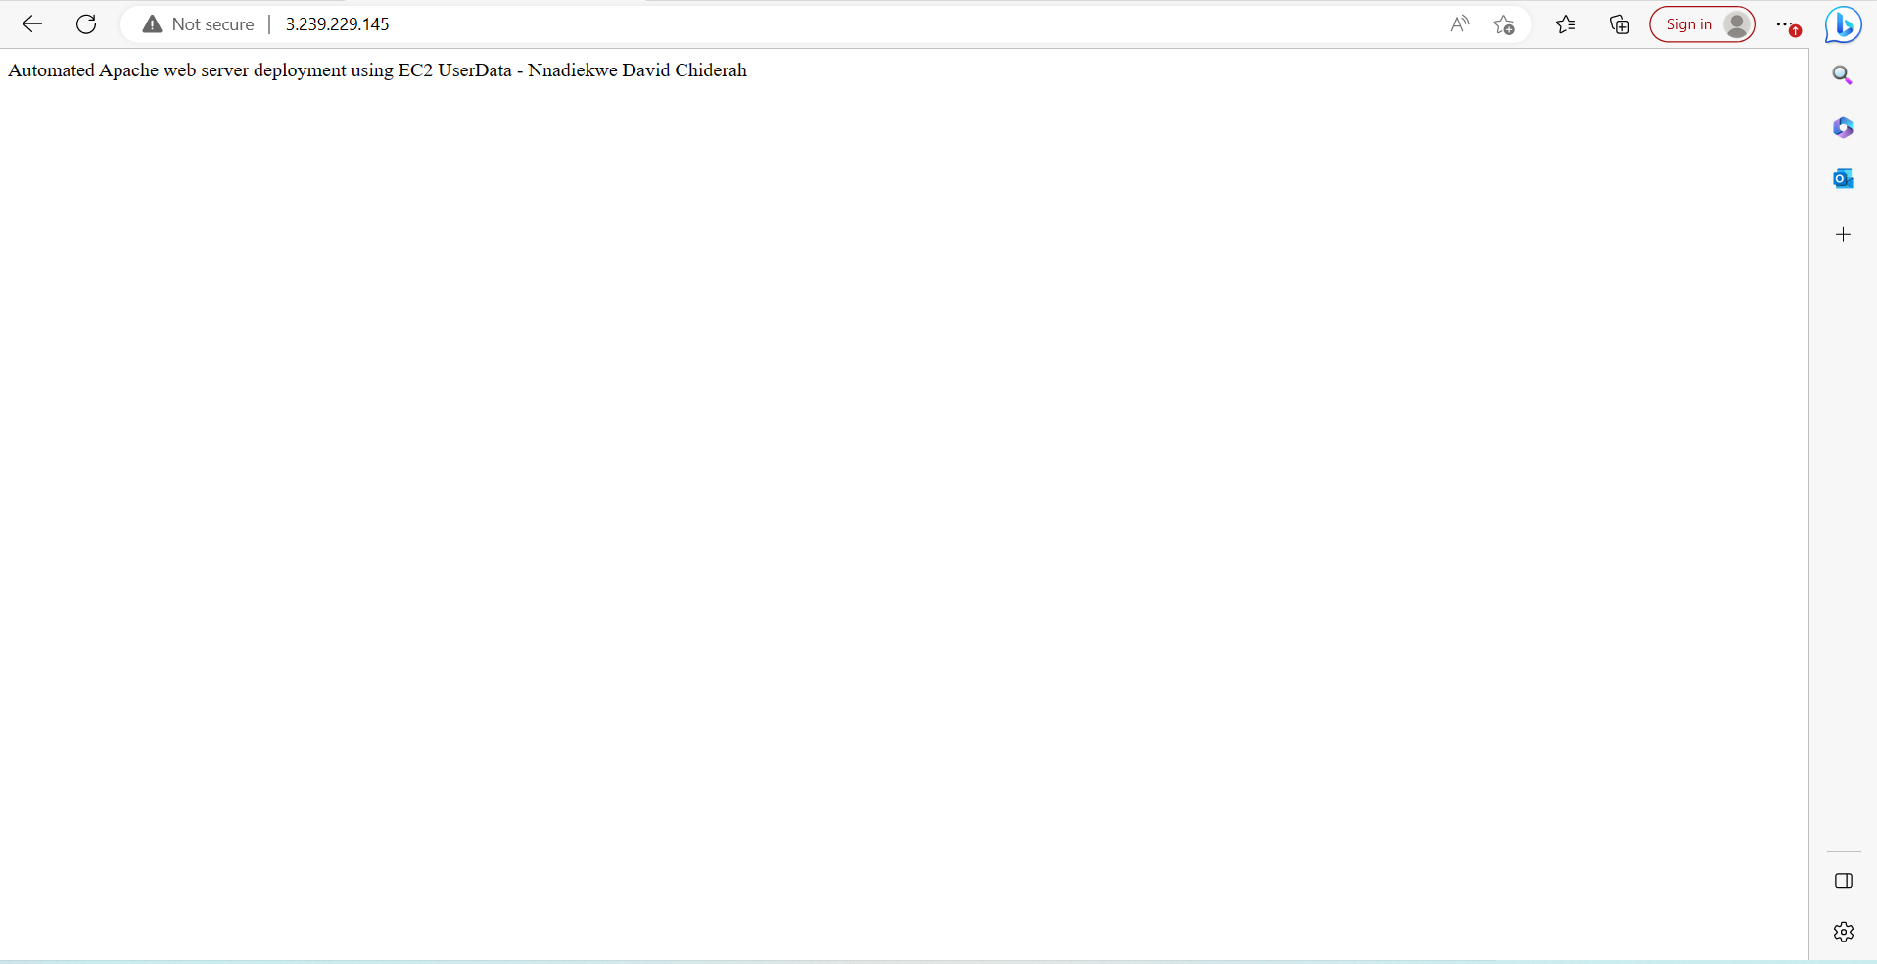

* ***Create an AMI of the instance by selecting the instance in the EC2 console and choosing the “Create Image” option.***

* ***Share the AMI with one member of your cluster.***

I shared my AMI with team member

* ***Team member confirmed receipt of the AMI in his account:***

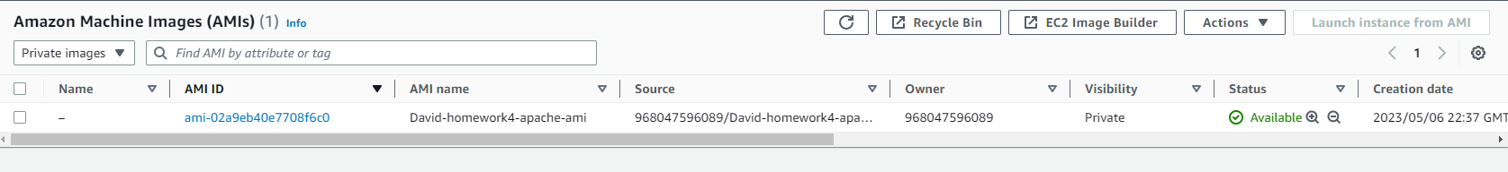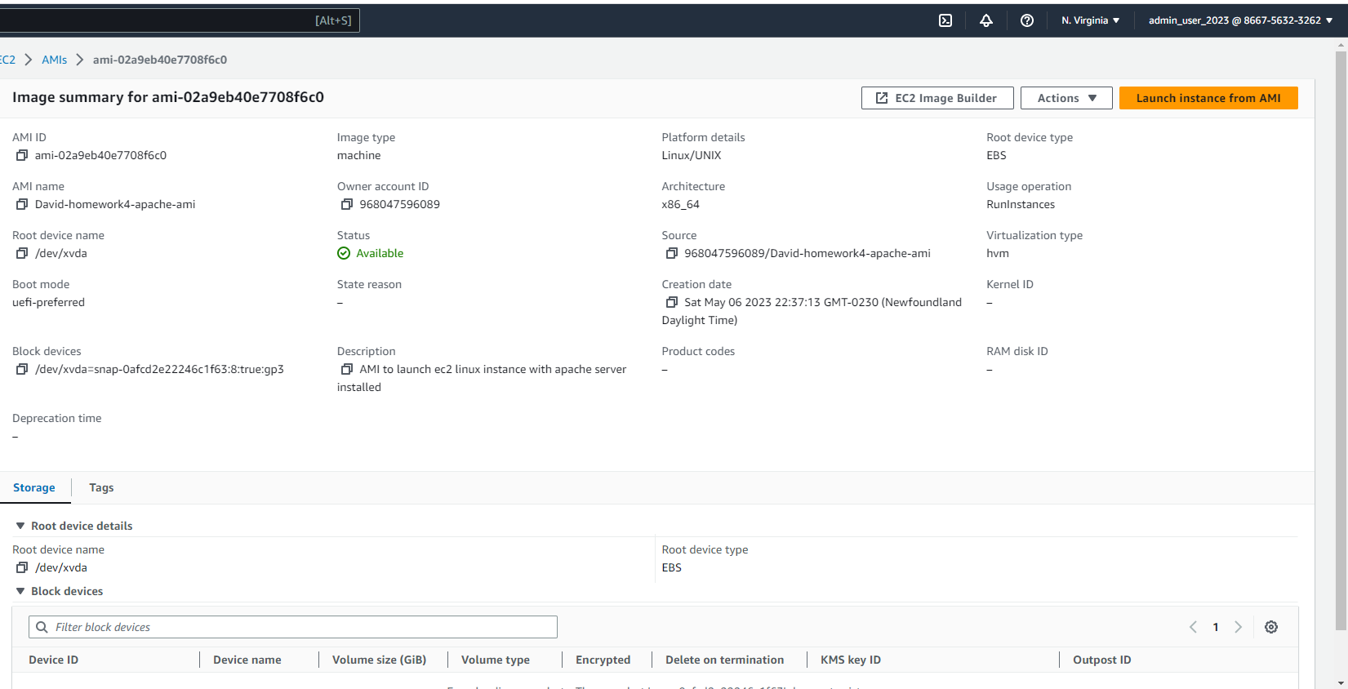

* ***New EC2 Launched using the AMI Template***

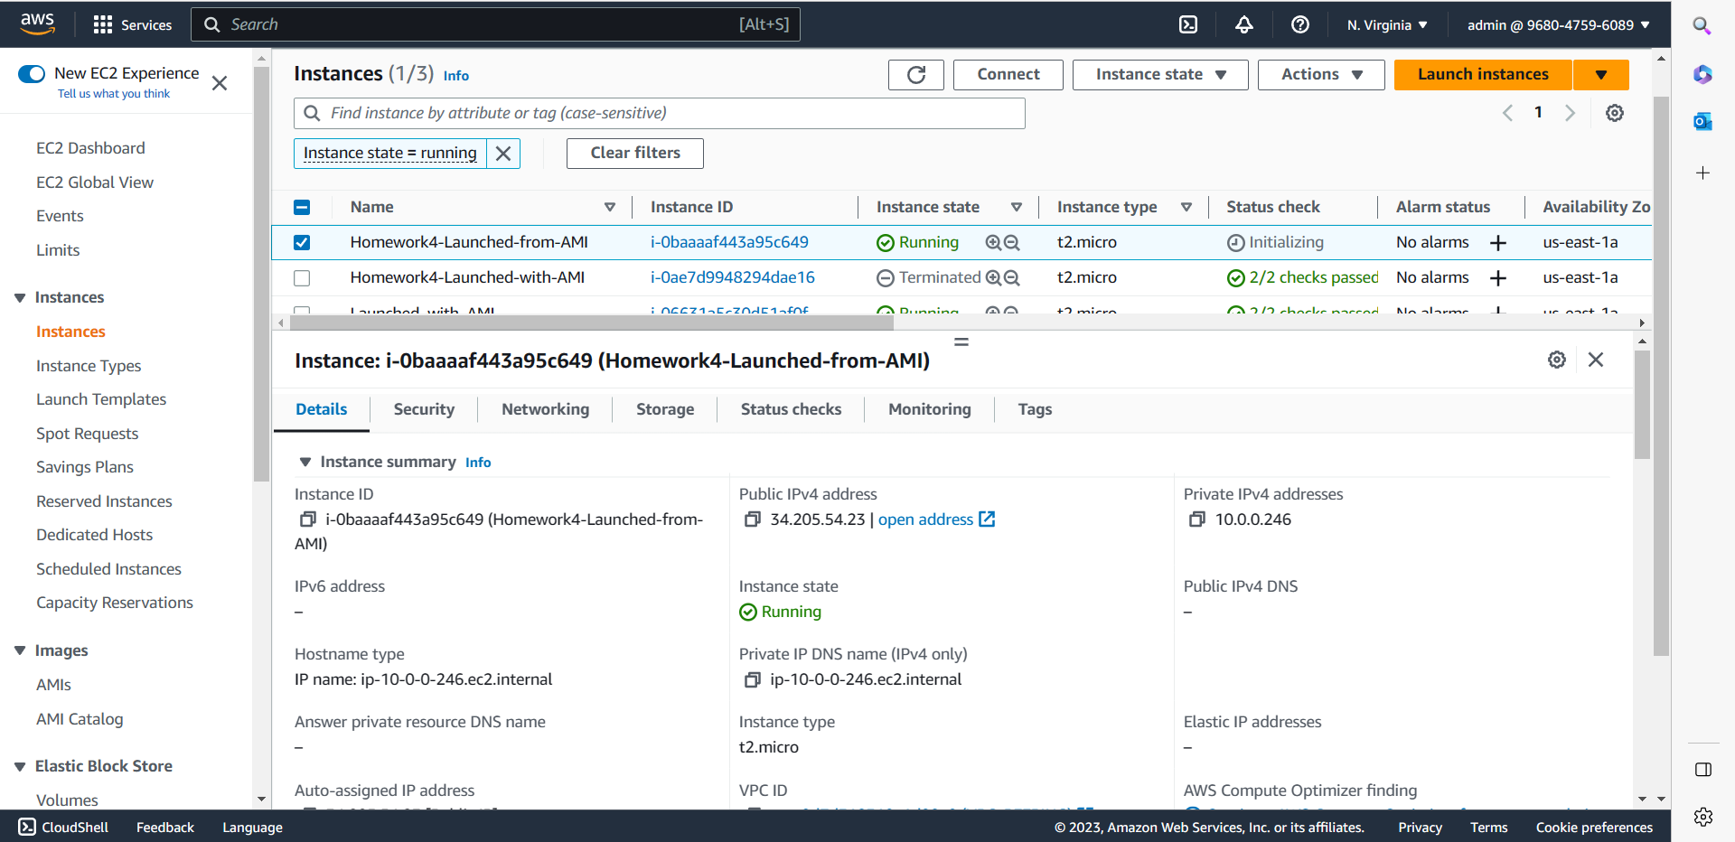

* ***Verification that the new ec2 is running Apache http web server***

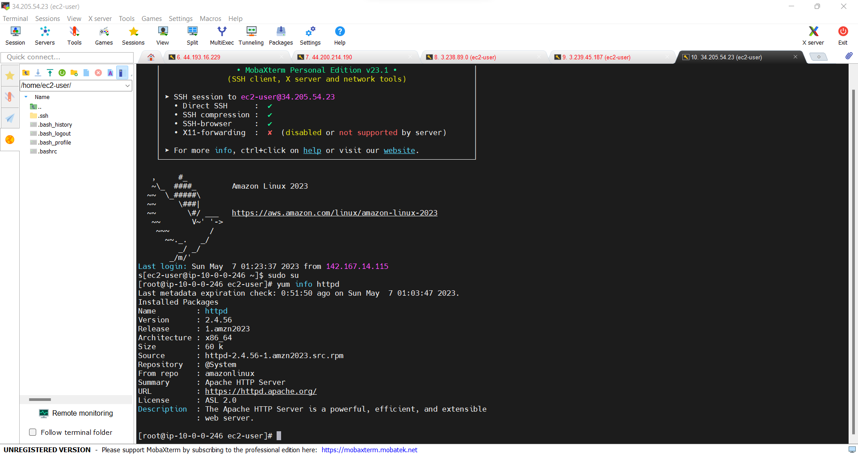

* ***Verification that the new ec2 is serving the same webpage as the previous ec2 instance***

***Note: Both the previous ec2 instance and the new ec2 instance created from the AMI displayed the same webpage***